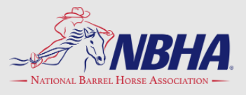
Saturday
SAT
PICKUP
RACE
$20
TEAM
Red, White & Blue Show
July 2, 3 and 4th
^{Montcalm County Fairgrounds}
^{8784 Peck Rd.}
^{Greenville, Mi. 48838}

SANCTIONED FOR DISTRICTS MI 00, MI 03 AND MI 05
FRIDAY JULY 2ND SATURDAY JULY 3RD SUNDAY JULY 4TH
^{EXPOS 3-6PM $3 EACH/2 FOR $5} ^{EXPOS 9-11AM $3 EACH/2 FOR $5} ^{NO EXPOS}
^{JACKPOT BARRELS 7PM} ^{ENTER AT SHOW} ^{SHOW STARTS NOON} ^{SHOW STARTS 10AM}
RIDER NAME:_______________________________________________________________TEEN/YOUTH DOB:________________________
ADDRESS:______________________________________________CITY:__________________________________ZIP:___________________
PHONE:________________________NBHA#:_________________DISTRICT:___________________ MI00 SHOW COUNT? YES NO
 | ^{FEE} | ^{HORSE #1 NAME} |  |  | ^{HORSE #2 NAME} |  |  | ^{HORSE #3 NAME}
^{SAT 3D POLES $50 ADDED} | ^{$15}
^{SAT JACKPOT 4D $100 ADDED} | ^{$15}
^{SAT NBHA/IBRA 4D $1500 ADDED}  ^{($2 IBRA PROC FEE INCLUDED)} | ^{$37}
^{SAT SIDEPOT MEN WOMEN} | ^{$10}
^{SAT NBHA SENIOR 3D $100 ADDED} | ^{$15} |  |  | ^{R} |  | ^{R} |  |  |  | ^{R}
^{SAT NBHA/IBRA YOUTH 3D $100+} | ^{$15} |  |  | ^{R} |  | ^{R} |  |  |  | ^{R}
^{SAT IBRA MASTERS 3D} | ^{$10} |  |  | ^{R} |  | ^{R} |  |  |  | ^{R}
^{SAT IBRA ADULT 3D} | ^{$10} |  |  | ^{R} |  | ^{R} |  |  |  | ^{R}
^{SUN NBHA/IBRA 4D $1000 ADDED}  ^{($2 IBRA PROC FEE INCLUDED)} | ^{$32}
^{SUN SIDEPOT MEN WOMEN} | ^{$10}
^{SUN NBHA SENIOR 3D $75 ADDED} | ^{$15} |  | ^{R} |  |  |  | ^{R} |  | ^{R}
^{SUN NBHA/IBRA YOUTH 3D $75+} | ^{$15} |  | ^{R} |  |  |  | ^{R} |  | ^{R}
^{SUN IBRA MASTERS 3D} | ^{$10} |  | ^{R} |  |  |  | ^{R} |  | ^{R}
^{SUN IBRA ADULT 3D} | ^{$10} |  | ^{R} |  |  |  | ^{R} |  | ^{R}
ALL CLASSES ARE 70% PAYBACK-ANY CHECKS NOT PICKED UP WILL BE HELD UNTIL CLAIMED
TOTAL ENTRY FEE’S FROM ALL HORSES/CLASSES ABOVE ENTRY TOTALS:______________
CAMPING $30/NIGHT ELECTRIC-WATER X # OF NIGHTS_________PRIMITIVE $20/NIGHT X # NIGHTS__________CAMPING TOTAL:_____________
STALLS….(ALL OVERNIGHT STAYS MUST BE STALLED/DIRT FLOORS)…. $45/WEEKEND X STALLS:______________ STALL TOTAL:________________
NON MEMBER FEE (IF NOT NBHA OR IBRA) $10/RIDER MEMBERSHIPS AVAILABLE AT SHOW _______________
PROCESS FEE $5 PER HORSE/RIDER FOR EACH DAY PROCESS FEE:______________
TOTAL FEES DUE NBHA MI 03:____________
ENTRIES DUE (POSTMARKED) JUNE 25TH OR LATE FEE APPLIES OF $10 PER HORSE/RIDER COMBINATION
MAIL COMPLETED FORM WITH PAYMENT TO: NBHA MI 03 JERI WITZEL, 8326 Kohler Rd, Howard City, Mi. 49329
QUESTIONS?? CALL/TEXT JERI @ 231-519-0554

^{GENERAL INFORMATION:}
ALL HORSES STAYING OVERNIGHT MUST BE STALLED, FAIRGROUND RULES. STALLS ARE DIRT FLOORS.
NO HORSES IN CAMPING AREAS OR LIVESTOCK BARNS/ARENA.
NO CAMPING OR TYING OF HORSES NEXT TO OTHER FAIRGROUND BUILDINGS/BARNS. WE (YOU) ARE RESPONSIBLE FOR ANY DAMAGE TO FAIRGROUND BUILDINGS.
FOOD VENDOR WILL BE ONSITE (Lions Club in Cafeteria Building)
DRESS CODE WILL BE NBHA, IBRA WEAR, COLLARED SHIRT OR RWB APPAREL. NO BALL CAPS.
RWB T-SHIRTS & TANKS WILL BE AVAILABLE FOR SALE, QUANITITES WILL BE LIMITED
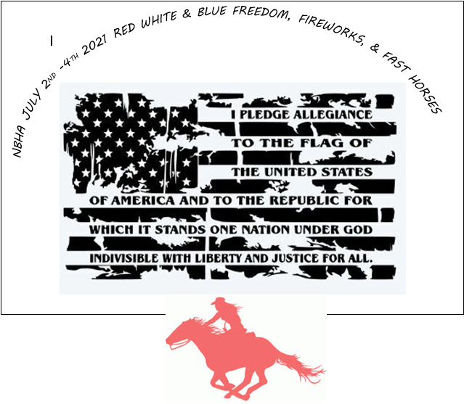
MAVERICK CLASS DAILY-WILL RUN PRIOR TO ANY OTHER BARREL CLASS-$5
YOU MAY ROLL YOUR TIME FROM THE OPEN CLASS ONLY.
CLASSES ARE 70% PAYBACK OF ENTRY FEE, 100% OF ADDED MONEY. CHECKS NOT CLAIMED WILL BE HELD UNTIL PICKUP.
FRIDAY NIGHT JACKPOT: OPEN CLASS ONLY, $20 +$5 PROCESS FEE…….80% PAYBACK. ENTER AT SHOW. $200 ADDED.

